Ex. No. 02 | ADAPTIVE AND RESPONSIVE UI DESIGN
Date of Exercise | 25.08.2026
Git-hub Host Link | https://urk23cs1203.github.io/Flutter-Lap-Ex2/

Aim:
To create a Flutter application that automatically adapts its layout according to the available screen size.
Description:
This experiment demonstrates the development of a responsive Flutter application that automatically changes its user interface according to the screen width. The application uses LayoutBuilder to provide different layouts for mobile, tablet, and desktop-sized screens.

The main concepts include:
- Flutter & Dart – Framework and programming language used for developing the application.
- MaterialApp & Scaffold – Provide the basic application structure and screen layout.
- StatelessWidget – Creates a non-changing user interface.
- LayoutBuilder – Determines the available screen size and builds the appropriate layout.
- Constraints – Provides the maximum available width and height to the layout.
- Responsive UI – Automatically adjusts the application interface according to screen size.
- Column – Arranges widgets vertically for smaller screen sizes.
- Row – Arranges widgets horizontally for larger screen sizes.
- Card – Displays student and course information in an organized format.
- Expanded – Allows widgets in a Row to share the available horizontal space.
- Alignment & Spacing – Controls the position and spacing of widgets.
- Screen Size Testing – Tests the application by resizing the browser window or using different emulator sizes.

Procedure:
Step 1: Open the Terminal and verify that Flutter is installed correctly by executing flutter doctor. Step 2: Check the available Android emulator or connected devices using flutter devices.
Step 3: Create a new Flutter project by executing flutter create responsive_ui.
Step 4: Navigate to the project directory using cd responsive_ui.
Step 5: Open the project in Visual Studio Code using code .
Step 6: Open the lib/main.dart file and remove the default Flutter code.
Step 7: Create the responsive layout using the LayoutBuilder widget and check the available screen width.
Step 8: Create the mobile layout using a Column containing cards for Student and Courses.
Step 9: Create the desktop/tablet layout using a Row containing expanded cards for Students and Courses.
Step 10: Add Card, ListTile, and Expanded widgets to organize the information according to the available screen size.
Step 11: Save the main.dart file and execute flutter run in the Terminal.
Step 12:Resize the browser window or use different emulator sizes and verify that the application automatically changes from a Column layout on smaller screens to a Row layout on larger screens.
1
Ex. 2 | Adaptive and Responsive UI Design

Program:

import 'package:flutter/material.dart';
void main() {
runApp(const MyApp());
}
class MyApp extends StatelessWidget {
const MyApp({super.key});
@override
Widget build(BuildContext context) {
return MaterialApp(
debugShowCheckedModeBanner: false,
title: 'Responsive UI',
home: const ResponsiveHomePage(),
);
}
}
class ResponsiveHomePage extends StatelessWidget {
const ResponsiveHomePage({super.key})

@override
Widget build(BuildContext context) {
return Scaffold(
appBar: AppBar(
title: const Text('Adaptive and Responsive UI'),
),
body: LayoutBuilder(
builder: (context, constraints) {
// Mobile layout
if (constraints.maxWidth < 600) {
return Column(
children: [
Card(
margin: const EdgeInsets.all(10),
child: const ListTile(
leading: Icon(Icons.person),

2
Ex. 2 | Adaptive and Responsive UI Design

title: Text('Student'),
subtitle: Text('Mobile Layout'),
),
),
Card(
margin: const EdgeInsets.all(10),
child: const ListTile(
leading: Icon(Icons.book),
title: Text('Courses'),
subtitle: Text('Mobile Layout'),
),
),
],
);
}
// Desktop / Tablet layout
return Row(
children: [
Expanded(
child: Card(
margin: const EdgeInsets.all(10),
child: const ListTile(
leading: Icon(Icons.people),
title: Text('Students'),
subtitle: Text('Desktop / Tablet Layout'),
),
),
),
Expanded(
child: Card(
margin: const EdgeInsets.all(10),
child: const ListTile(
leading: Icon(Icons.school),
title: Text('Courses'),
subtitle: Text('Desktop / Tablet Layout'),
), ), ), ], ); }, ), ); } }

7
Ex. 2 | Adaptive and Responsive UI Design

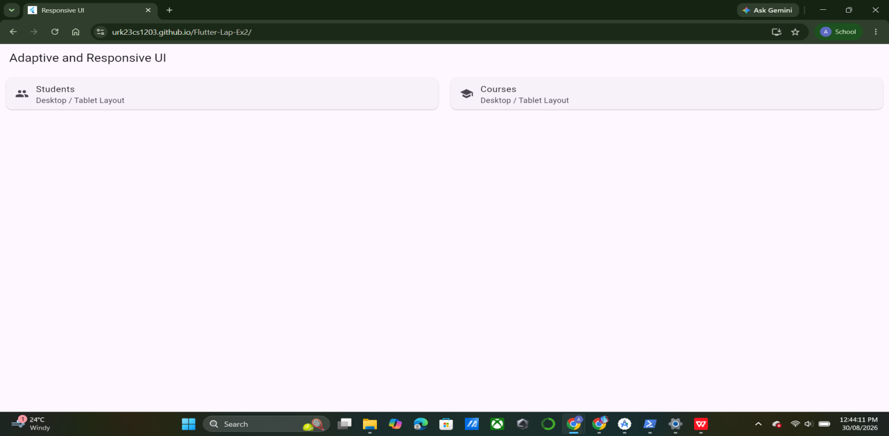
Output:

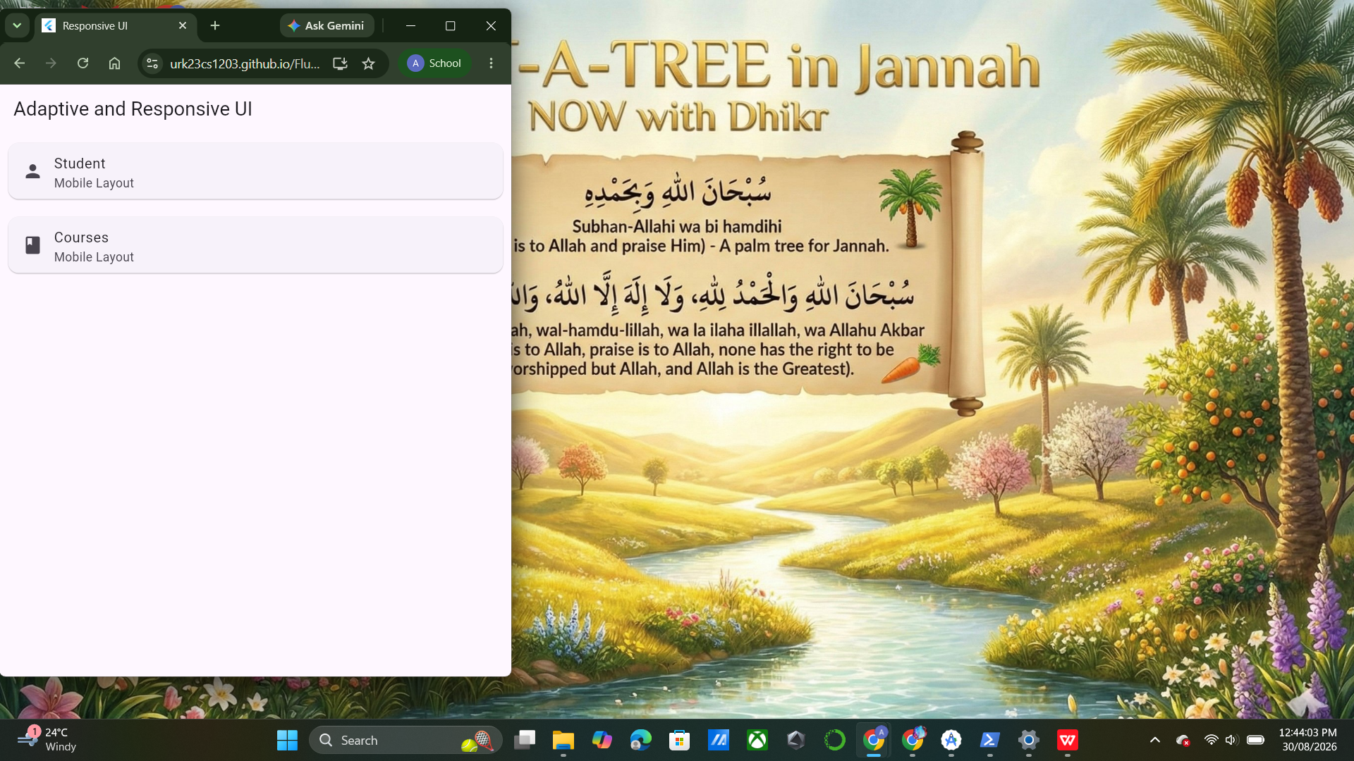
Result:
A Flutter responsive UI application was successfully developed using LayoutBuilder, Column, Row, Card, ListTile, and Expanded widgets. The application automatically adapts its layout according to the available screen size.

8
Ex. 2 | Adaptive and Responsive UI Design

